**Data Visualizations**

1. To find relationship between physical activity and obesity level:

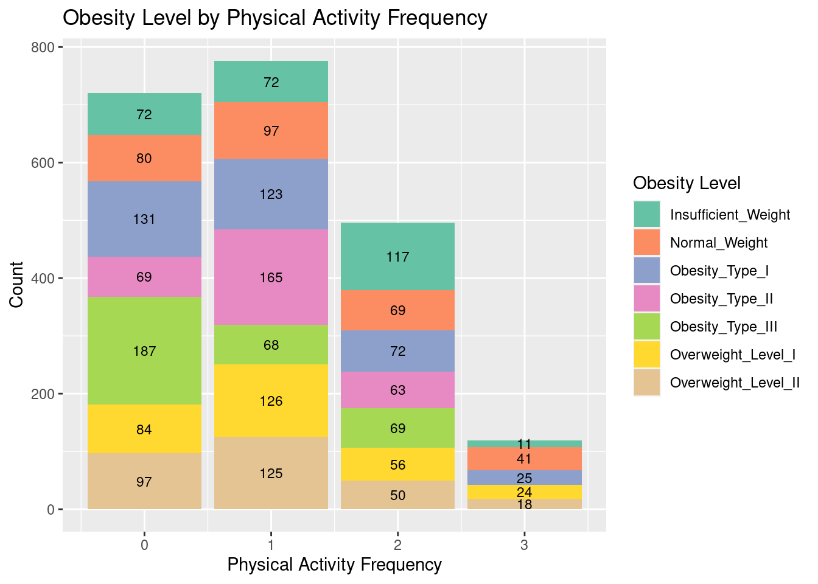

2. Age Distribution Across Obesity Levels:

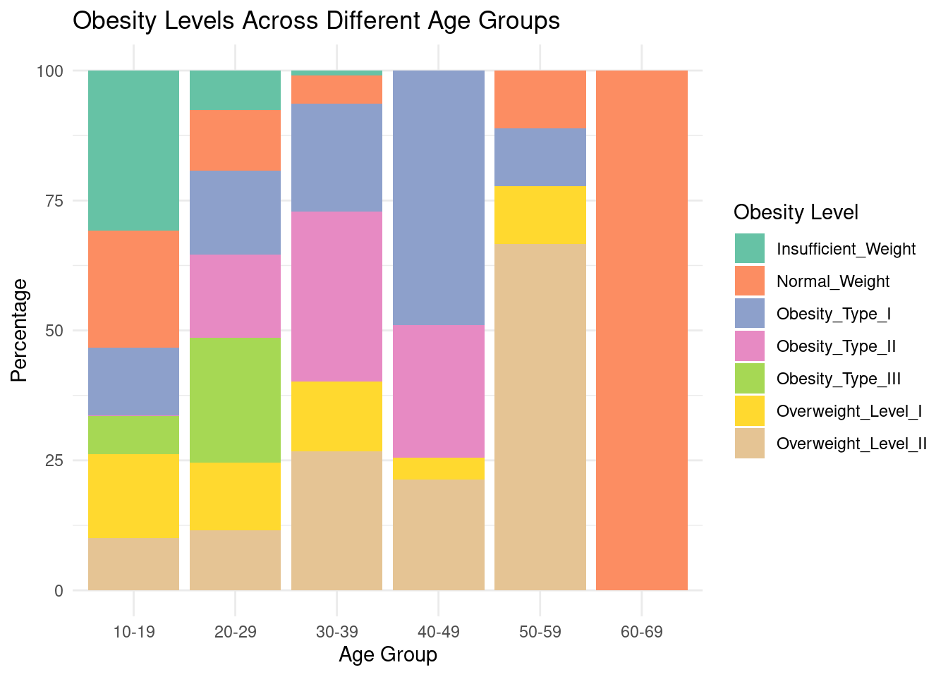

3. Impact of alcohol consumption and smoking on Obesity:

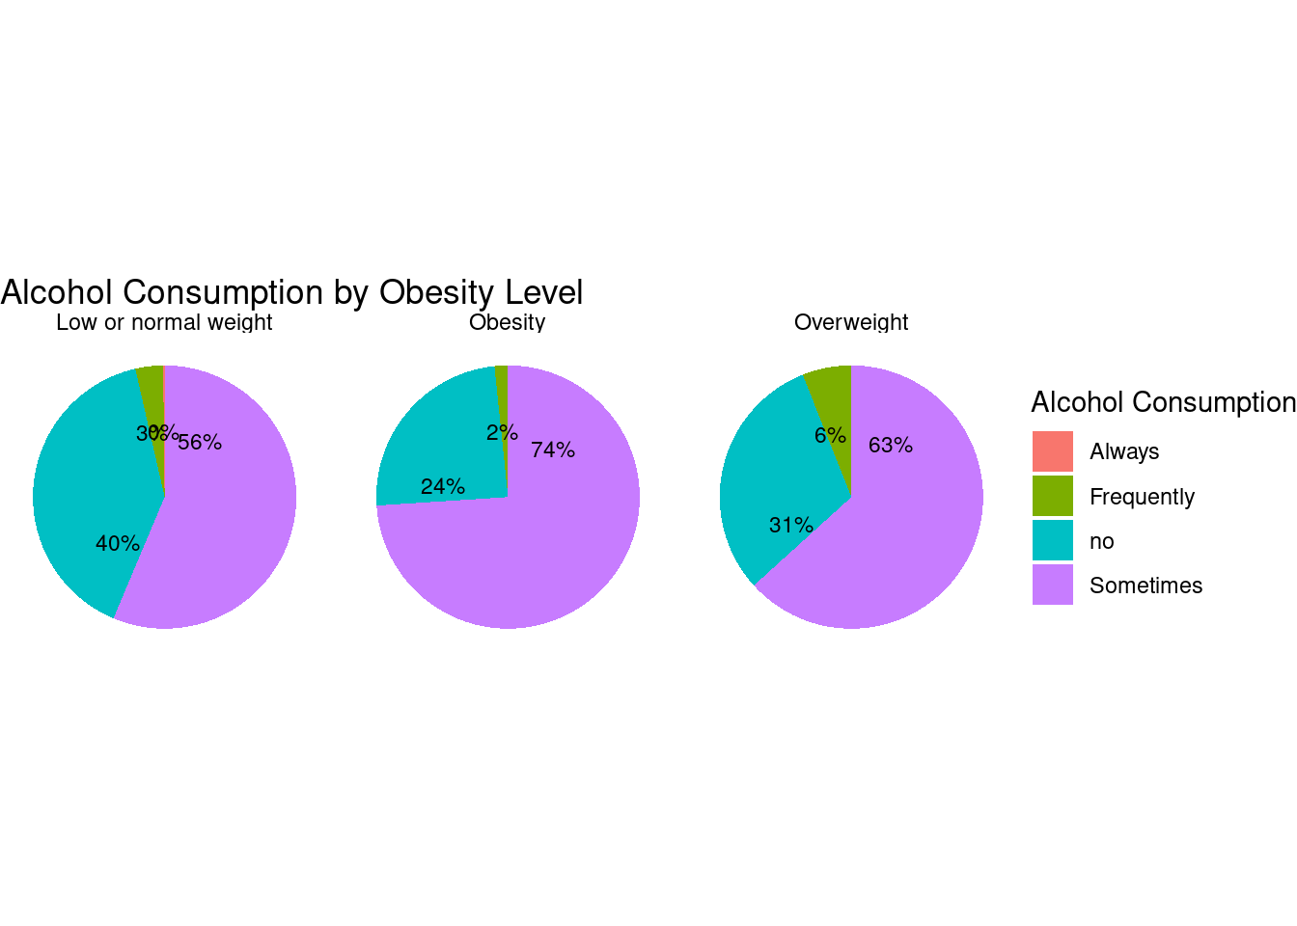

4. Prevalence of dietary factors and their overall impact on Obesity levels:

* Calorie monitoring (SCC)
* Consumption of high-caloric food (FAVC)
* Inclusion of vegetables in meals (FCVC) : Never(1), Sometimes(2), Always(3)
* Number of main meals (NCP) : Between 1 and 2(1), Between 2-3(2), Between 3-5(3), More than 5(4)
* Snacking habits (CAEC)
* Water intake (CH2O): <1L(1), 1-2L(2), >2L(3)